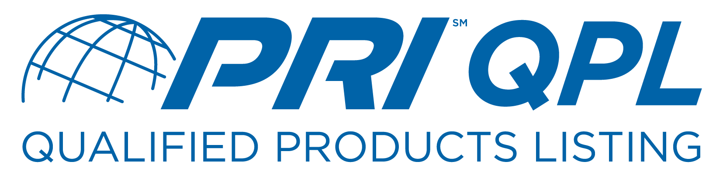
PRI Lubricant QPL Affidavit Form #1
Original Qualification

Company Name:
Company Address:

Contact Name:
Phone:
FAX:
Email:

I/We do here by certify that this company
^{(Company Official Name)} ^{(Company}
has verified the formulation listed below has been tested in accordance with the
^{Name)}
applicable performance and laboratory tests, as required by the standard identified below, and in

agreement with LRI procedures. This formulation was presented and accepted at the following LRI

Meeting/Program .
^{(LRI Meeting/Program #)}

(Attach appropriate completed and signed LRI Forms 1, 2, 2a, and 3 as needed)

Formulation Name/Code:
Brand Name:
SAE Standard:
SAE Viscosity:
Plant Blending Approval Granted: . *Required only if manufacturing/blending
^{(LRI Meeting/Program #)}

Notary Seal
Corporate Official Name & Title

Corporate Official Signature

Date Notary Signature

↓ PRI Use Only ↓

Date Submitted QPL Assignment Number
Date Accepted Staff Signature

