PRI Lubricant QPL Affidavit Form #5
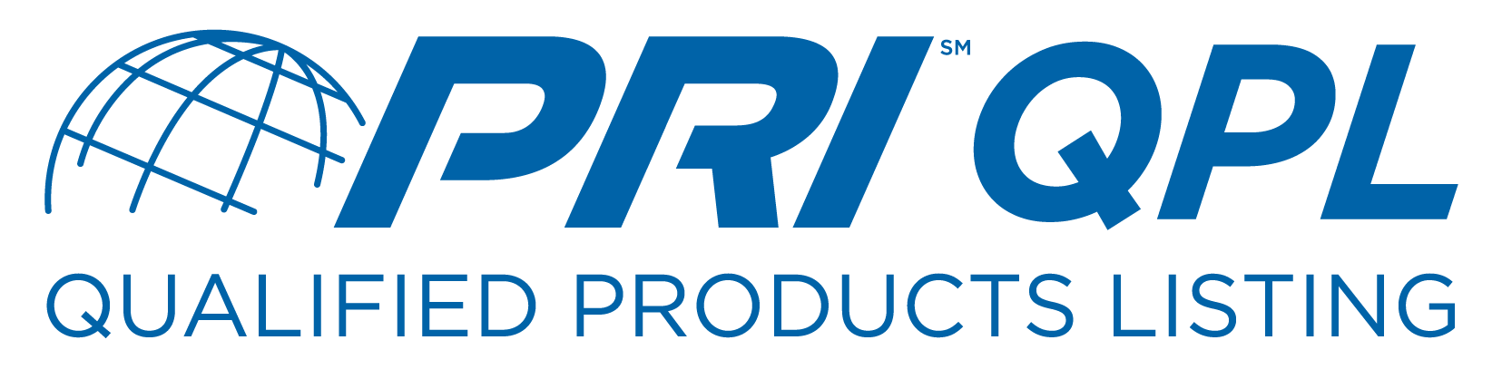
Rebrand Request for Qualification

Company Name:
Company Address:

Contact Name:
Phone:
FAX:
Email:

I/We do here certify we will market _____________
^{(Company Official Name)} ^{(Qualified Lubricant}
as a finished lubricant accepted at LRI Meeting/Program
^{Brand Name)} ^{(LRI Meeting/Program #)}
and assigned PRI QPL # as evidenced by the attached signed and executed PRI
^{(PRI QPL #)}
QPL Affidavit under the brand name listed below.

(Attach appropriate PRI Affidavit as needed)

Rebrand Lubricant Name:
SAE Standard:
SAE Viscosity:

Notary Seal
Rebrand QPL Corporate Official Name & Title

Rebrand QPL Corporate Official Signature

Date Notary Signature

↓ PRI Use Only ↓

Date Submitted Rebrand QPL Assignment Number

Date Accepted Staff Signature

